## Supporting Information

**Table S1.** Binding sites of CD147 obtained from MOE (Site Finder).

|  |  |
| --- | --- |
| **Binding Sites** | **Residues** |
| Site1 | S78 D79 D80 Q81 W82 G83 Q100 L101 HID102 G103 P104 P105 R106 E129 S130 V131 P132 S193 D194 |
| Site2 | A109 V110 K111 E114 M123 L124 V125 I198 |
| Site3 | W137 A138 W139 L150 M151 N152 V160 N186 |
| Site4 | R106 V107 K108 K127 S128 E129 Q164 G165 R166 |
| Site 5 | HIP53 W55 L62 E64 L67 K71 T72 E73 |
| Site 6 | L38 L62 E73 F74 K75 |
| Site 7 | K57 V61 F74 D80 W82 Y85 |
| Site 8 | I37 Q81 Q100 L101 HID102 G103 P104 N44 |
| Site 9 | K57 W82 G83 E84 Q100 E129 |

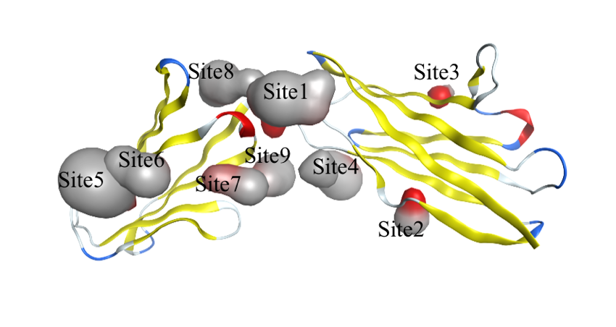

**Figure S1.** Binding sites of CD147 protein obtained from MOE (Site Finder).

**Table S2.** Binding sites of α7nAChr obtained from MOE (Site Finder).

|  |  |  |
| --- | --- | --- |
| **Binding Sites** | **Conformation** | **Residues** |
| Site1 | Desensitized | (K45 N46 Q47 S126 C127 A257 E258 M260 P261 A262 T263) and (Q38 I39 M40 D41 V42 D43 E44 K45 F134 P169 N170 G171 E172 W173 R205 Y209 Y210 N213 L214 L255 V256 E258 I259 M260) |
| Site2 | Desensitized | Y7 R78 F79 P80 D81 F103 H04 T105 N106) and (P16 L17 E18 L55 M57 D81 I84 W85 K86 P87 D88 I89 L90 D100 T102 H04 Y117 P119 S149 Y150 |
| Site3 | Desensitized | (Y92 S147 W148 S149 Y150 W153 Y187 C189 C190 K191 E192 Y194) and (W54 T76 R78 T105 N106 V107 L108 N110 Q116 Y117 L118 P119) |
| Site4 | Desensitized | (Q47 Y92 N93 S126 C127 Y128 H40 C141 K142 K144 Y187 T200) and (L37 Q38 N52 W54 I168 P169 N170) |
| Site 1 | Activated | (K45 N46 Q47 V48 A95 E97 K124 S126 C127 Y128 M253 L254 A257 E258 M260 P261 A262 T263) and (Q38 I39 M40 D41 V42 D43 E44 K45 T50 I122 I168 P169 N170 E172 W173 R205 Y209 Y210 N213 L214 F252 L255 E258 I259 M260) |
| Site 2 | Activated | (R19 D24 S25 Q26 P27 Y92 S147 W148 S149 G151 W153 S154 Y187 C189 C190 K191 E192 Y194) and (Q3 W54 G73 V74 K75 T76 R78 T105 N106 L108 N110 Q116 Y117 L118 P119) |
| Site 3 | Activated | (P16 L17 M57 D81 G82 I84 W85 K86 P87 D88 I89 L90 D100 T102 H04 Y117 P119 W148 S149 Y150) and (Y7 R78 F79 P80 F103 H04 T105 N106) |
| Site 4 | Activated | (V287 I290 V291 Y294 HID295 P299 D300 G302 K303 P305 T308 R309 L312 E436 W437 A440 V444) |
| Site 1 | Resting | (P16 L17 R19 D24 S25 Q26 P27 L55 M57 D81 G82 I84 W85 K86 P87 D88 I89 L90 Y92 D100 T102 HIP104 Y117 P119 S147 W148 S149 Y150 G151 W153 S154 Y187 C189 C190 E192 Y194) and (Q3 Y7 G73 V74 K75 T76 V77 R78 F103 T105 N106 L108 Q116 Y117 L118) |
| Site 2 | Resting | (Q3 G73 V74 K75 T76 R78 T105 N106 L108 Q116 Y117 L118) and (R19 D24 S25 Q26 P27 Y92 S147 W148 S149 Y150 G151 W153 S154 Y187 C189 C190 E192 Y194) |
| Site 3 | Resting | (P16 L17 L55 M57 D81 G82 I84 W85 K86 P87 D88 I89 L90 D100 T102 HIP104 Y117 P119 W148 S149 Y150) and (Y7 R78 F103 HIP104 T105 N106) |

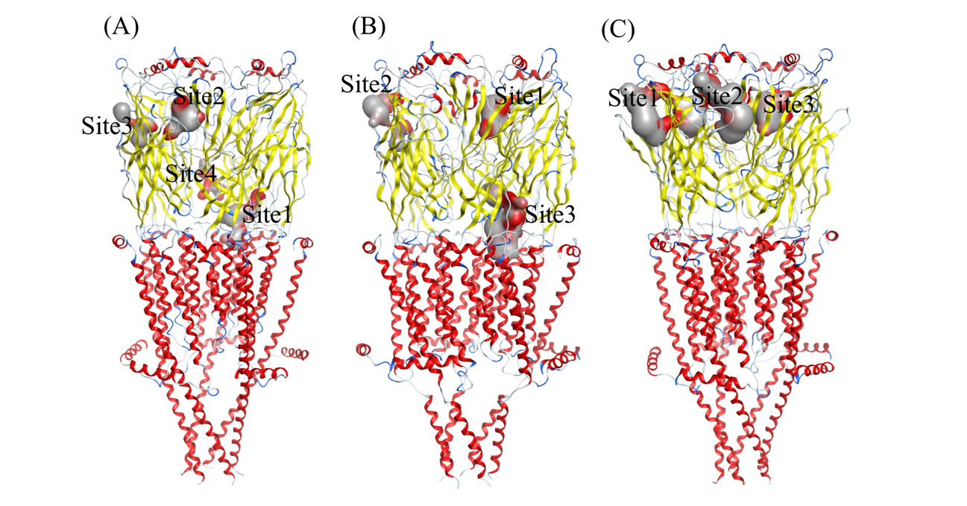

**Figure S2.** Binding sites of (**a**) desensitized, (**b**) activated and (**c**) resting conformations of α7nAChr protein obtained from MOE (Site Finder).

**Table S3.** Results of the docking analysis of Ivermectin for spike protein S1 on all binding sites on NTD and RBD in open and closed positions. The highest S-score (in absolute value) was obtained for NTD Site 10, in the open position.

|  |  |  |  |  |  |  |  |
| --- | --- | --- | --- | --- | --- | --- | --- |
| **Open** | | | | **Closed** | | | |
| **NTD** | | **RBD** | | **NTD** | | **RBD** | |
| **Score (kcal/mol)** | **Site** | **Score**  **(kcal/mol)** | **site** | **Score**  **(kcal/mol)** | **Site** | **Score**  **(kcal/mol)** | **Site** |
| -6.973 | Site 1 | -6.578 | site 16 | -7.045 | Site 1 | -6.46 | site 16 |
| -7.561 | Site 2 | -8.256 | site 17 | -7.175 | Site 2 | -6.743 | site 17 |
| -7.028 | Site 3 | -6.144 | site 18 | -7.183 | Site 3 | -6.748 | site 18 |
| -7.441 | Site 4 | -8.239 | site 19 | -8.205 | Site 4 | -6.424 | site 19 |
| -7.412 | Site 5 | -8.209 | site 20 | 0 | Site 5 | -6.603 | site 20 |
| -7.522 | Site 6 | -7.813 | site 21 | -7.246 | Site 6 | -6.856 | site 21 |
| -6.343 | Site 7 | -7.513 | site 22 | -6.031 | Site 7 | -7.735 | site 22 |
| -5.794 | Site 8 |  |  | -6.308 | Site 8 |  |  |
| -6.735 | Site 9 |  |  | -6.913 | Site 9 |  |  |
| -8.948 | Site 10 |  |  | -7.497 | Site 10 |  |  |
| -6.955 | Site 11 |  |  | -7.032 | Site 11 |  |  |
| -6.149 | Site 12 |  |  | -6.258 | Site 12 |  |  |
| -7.057 | Site 13 |  |  | 0 | Site 13 |  |  |
| -7.108 | Site 14 |  |  | -6.67 | Site 14 |  |  |
| -7.663 | Site 15 |  |  | -7.081 | Site 15 |  |  |

**Table S4.** Results of the docking analysis of Ivermectin on all sites of CD147.

|  |  |
| --- | --- |
| **CD147** | |
| **Score**  **(kcal/mol)** | **Site** |
| -7.527 | site 5 |
| -7.468 | site 2 |
| -7.436 | site 6 |
| -7.233 | site 12 |
| -7.136 | site 1 |
| -6.943 | site 8 |
| -6.758 | site 9 |
| -6.745 | site 7 |
| -6.703 | site 4 |
| -6.611 | site 3 |
| -6.379 | site 11 |
| -6.356 | site 10 |

**Table S5.** Results of the docking analysis of Ivermectin on all sites of α7nAChr. Different values for one site are related to the same kind of site but for the different monomers of α7nAChr.

|  |  |  |  |  |  |
| --- | --- | --- | --- | --- | --- |
| **Α7nAChr** | | | | | |
| **Desensitized** | | **Activated** | | **Resting** | |
| **Score**  **(kcal/mol)** | **Site** | **Score**  **(kcal/mol)** | **Site** | **Score**  **(kcal/mol)** | **Site** |
| -8.798 | Site 1 | -9.047 | Site 3 | -6.341 | Site 3 |
| -7.514 | Site 1 | -8.938 | Site 3 | -9.375 | Site 1 |
| -7.855 | Site 1 | -8.986 | Site 3 | -8.828 | Site 1 |
| -9.086 | Site 3 | -8.918 | Site 3 | -8.398 | Site 1 |
| -9.047 | Site 3 | -6.246 | Site 1 | -8.518 | Site 1 |
| -8.751 | Site 3 | -8.317 | Site 3 | -7.89 | Site 2 |
| -8.694 | Site 3 | -6.632 | Site 1 | -9.619 | Site 2 |
| -9.147 | Site 3 | -7.345 | Site 1 | -9.392 | Site 2 |
| -6.002 | Site 2 | -7.988 | Site 1 | -9.593 | Site 2 |
| -6.622 | Site 2 | -6.111 | Site 1 |  |  |
| -6.594 | Site 2 | -10.581 | Site 2 |  |  |
| -8.943 | Site 2 | -10.636 | Site 2 |  |  |
| -7.996 | Site 2 |  |  |  |  |
| -7.591 | Site 1 |  |  |  |  |
| -8.798 | Site 1 |  |  |  |  |
| -7.514 | Site 4 |  |  |  |  |

## 

**Figure S3.** Ligand interaction plots of compounds selected for Spike inhibition. (**a**) Ivermectin, (**b**) Moxidectin, (**c**) Doramectin (**d**) Oleandrin, (**e**) Selamectin. A graphical key (**f**) is included to help interpret the 2-D part of the ligand interactions panel.

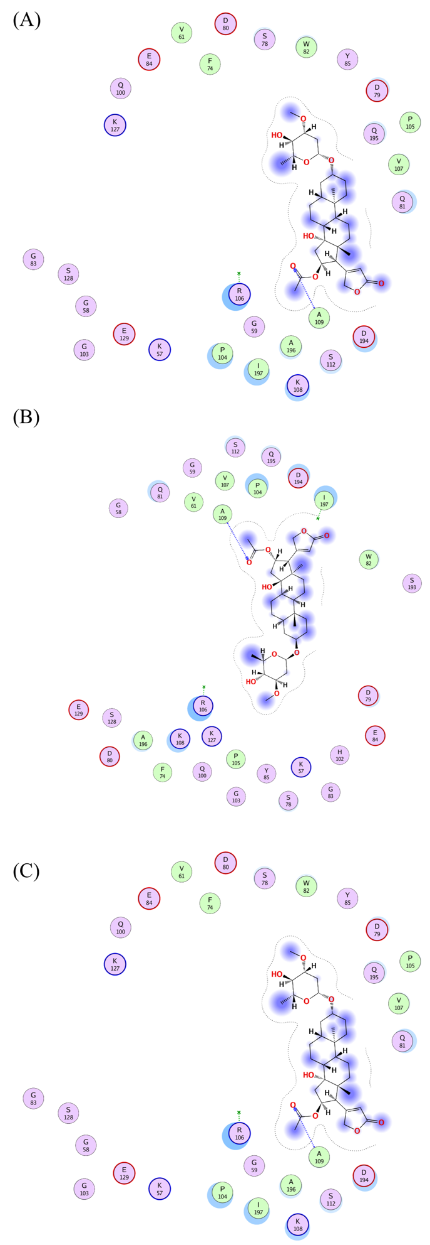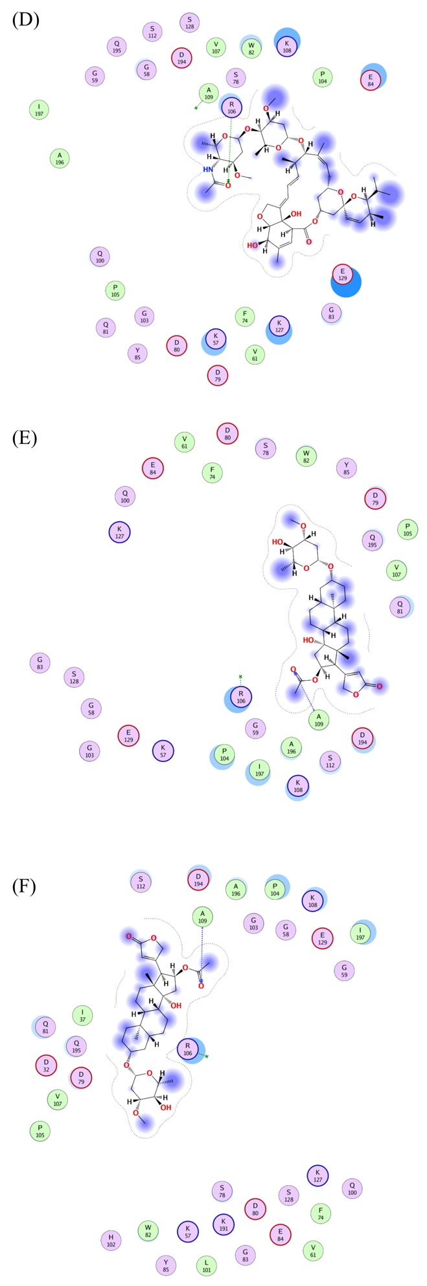

**Figure S4**. Ligand interaction plots of compounds selected for CD147 inhibition. (**a**) Okadaic_acid, (**b**) Doramectin, (**c**) Selamectin, (**d**) P-57AS3, (**e**) Concanamycin_A and (**f**) Ivermectin. A graphical key is included in Figure S3(f).

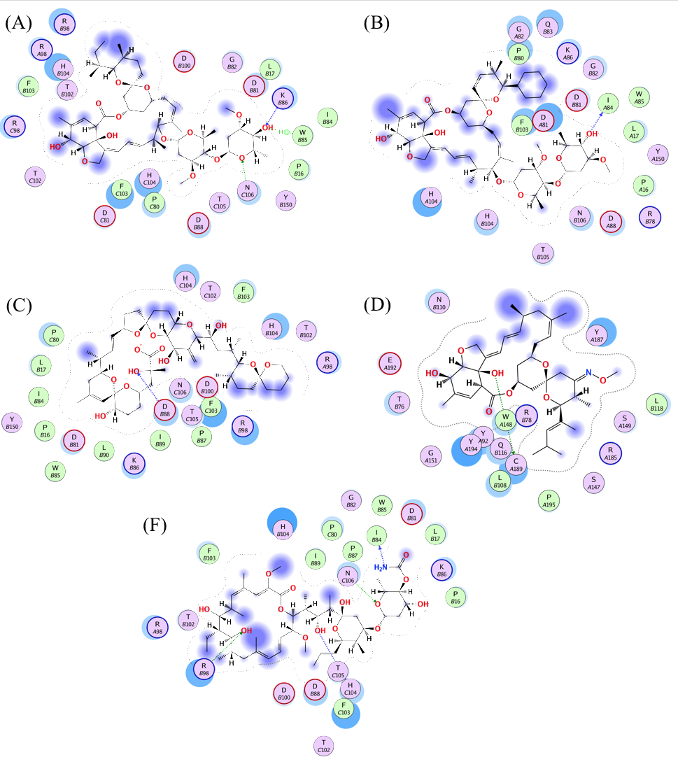

**Figure S5.** Ligand interaction plots of compounds selected for α7nAChr inhibition. (**a**) Ivermectin, (**b**) Doramectin , (**c**) Okadaic_acid, (**d**) Moxidectin, and (**e**) Concanamycin_A. A graphical key is included in Figure S3 (**f**).

**Table S6.** Amino acid mutations of SARS-CoV-2 Alpha, Beta, Gamma and Delta variants of SARS-CoV-2 with a focus on Spike protein. The domain to which each mutation belongs is indicated in parentheses.

|  |  |  |  |
| --- | --- | --- | --- |
| **B.1.1.7**  **(United Kingdom, Alpha)** | **B.1.351**  **(South Africa, Beta)** | **P.1**  **(Brazil, Gamma)** | **B.1.617.2**  **(India, Delta)** |
| H69–V70 deletion (NTD) | L18F (NTD) | L18F (NTD) | T19R (NTD) |
| Y144 deletion (NTD) | D80A (NTD) | T20N (NTD) | 157-158 Deletion (NTD) |
| N501Y (RBD) | D215G (NTD) | P26S (NTD) | L452 (RBD) |
| A570D | 242-244 deletion (NTD) | D138Y (NTD) | T478(RBD) |
| P681H | R246I (NTD) | R190S (NTD) | D614G |
| T716I | K417N (RBD) | K417T (RBD) | P681R |
| S982A | E484K (RBD) | E484K (RBD) | D950N |
| D1118H | N501Y (RBD) | N501Y (RBD) |  |
|  | D614G | D614G |  |
|  | A701V | H655Y |  |
|  |  | T1027I |  |
|  |  | V1176F |  |

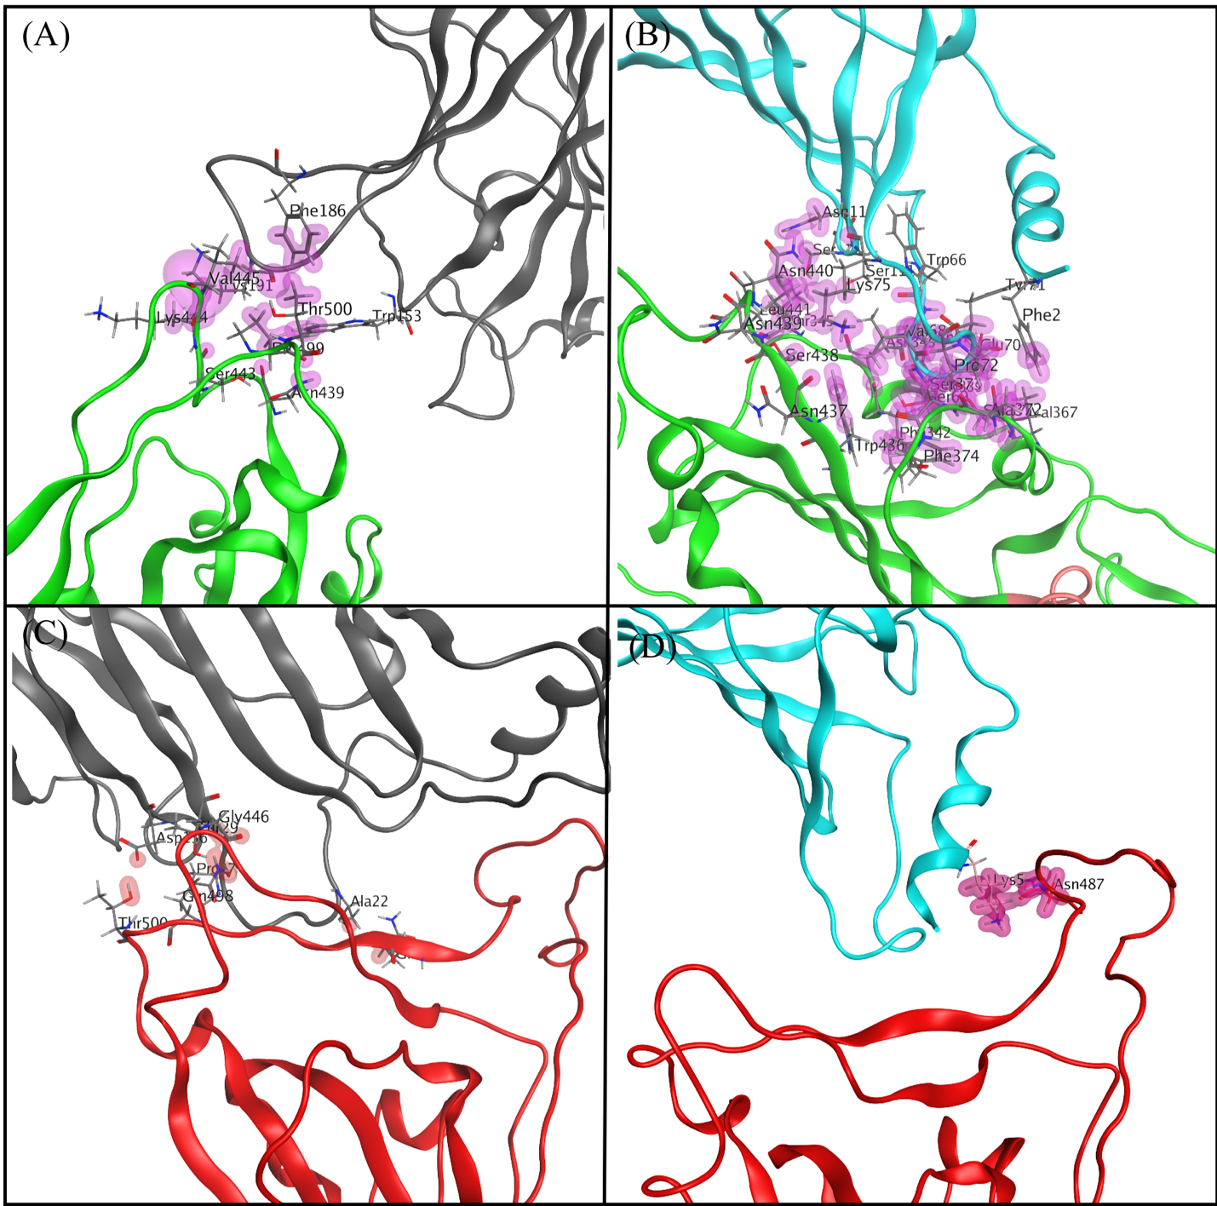

**Figure S6.** Protein-protein interaction between (a) chain E (gray) $α$ 7nAChr and chain C (green) of spike protein, (b) chain A (cyan) $α$ 7nAChr and chain C (green) of spike protein, (c) chain E (gray) $α$ 7nAChr and chain B (red) of spike protein, and (d) chain A (cyan) $α$ 7nAChr and chain B (red) of spike protein. For clarity purposes, we didn’t depict the VDW distance interactions in part (c) and (d).